EMPLOYMENT AGREEMENT

This **EMPLOYMENT AGREEMENT** (the “**Agreement**”) is made and executed on this 1st of April,2019 (hereinafter referred to as the “**Effective Date**”).

**BY AND BETWEEN**

1. **Bonfleet Solutions Private Limited**, a private company limited by shares incorporated in India and having its registered office at C-407, 4th Floor, Baner Biz Bay, Baner, Pune 411045, Maharashtra, India

(the “**Company**”);

**AND**

1. **Shilpa Hampanna Angadi - Flat-109, Nisarg Vatika, Borhadewadi, Moshi-412105** (the “**Employee**”).

(The Company and the Employee are hereinafter collectively referred to as the “**Parties**” and individually as a “**Party**”).

**RECITALS**

1. The Company is engaged in the business of operating an online electronic platform (“the Portal”) that (i) only assists banks and non-banking financial companies (“**NBFCs**”) to identify borrowers through its portal www.bon.pe which facilitates the banks and NBFCs to disburse the loan to the borrowers by loading the cards/wallets of the borrowers and for the borrower to accept the amounts disbursed by the banks and NBFCs and further facilitates in the banks and NBFCs to get re-payments made by borrowers against such loan and (ii) provides software services such as invoicing, payroll, KYC related compliances dashboard, communication and notification systems for better management of fleets and teams (“**Business**”).
2. The Employee has represented to the Company that he has the requisite skills, knowledge and experience necessary to render the functions and perform his duties as contemplated under this Agreement.
3. The Parties are desirous of entering into this Agreement to record the terms and conditions of the Employee’s employment with the Company.
4. The Parties have now agreed to enter into this Agreement in substitution and supersession of any and all other agreements and arrangements between the Company and the Employee, whether oral or in writing, in relation to the Employee’s employment with the Company.

**NOW, THEREFORE,** the Parties agree as follows:

1. **TERM OF EMPLOYMENT**
   1. The first three months of employment are considered a probation period. The probation period provides each staff member with the opportunity to learn and adjust to a new job, work environment and colleagues, and to demonstrate competence in the required duties. The probation period also provides the necessary time for the employee’s line manager to monitor, evaluate and provide feedback regarding an individual’s performance.
   2. In the event that an individual is unable to fulfil the duties and responsibilities as outlined in his or her Job Description, 90-Day Pre-Evaluation and Employment Agreement, BON reserves the right to terminate employment at any time during the probation period upon having given three days’ notice to the employee. During the probation period, employees may also terminate their employment upon having given three days’ notice to BON.
   3. On and from the Effective Date and subject to the terms and conditions contained in this Agreement, the Employee shall continue to be employed by the Company as Legal, Secretarial and Admin/HR Executive or such other designation as may be prescribed by the Company from time to time, and shall continue to be so employed by the Company until the termination of employment in accordance with Clause 9 of this Agreement.
   4. **Reporting -** You will report to Mr. Roshan Upadhyay, Vice -President
   5. **Salary -** Your salary will be a CTC of ___________ /- for the year, subject to satisfactory quarterly reviews..
   6. **Place of posting-** You will be posted at Pune, India. You may however be required to work at any place of business which the Company has, or may later acquire.
   7. The execution of this Agreement shall not be deemed to be a break in the employment of the Employee with the Company.
   8. **Hours of Work**

The normal working days are Monday through Friday. You will be required to work for such hours as necessary for the proper discharge of your duties to the Company. The normal working hours are from 10am to 7pm and you are expected to work not less than 40 hours each week, and if necessary, for additional hours depending on your responsibilities.

* 1. The Employee will get retired from service at the age of 65 (sixty-five). However, the Company may offer his consultancy services after the age of retirement and the Employee may continue rendering services to the Company as a consultant, if appointed, subject to meeting the criteria for consultancy services.

2. **DUTIES AND FUNCTIONS**
   1. From the Effective Date, the Employee shall continue to occupy the position and perform the duties as Legal,Secretarial,Admin/HR Executive of the Company. The Employee shall be subject to the control, direction and supervision of his supervisor, who shall be identified by the Company. The Employee shall fulfill such general duties and responsibilities as are consistent with such position and as are assigned to him from time to time by the Company. The Job description is communicated to your official email id, by your manager.
   2. The Employee shall devote all his business time, attention and energies to the business of the Company. The Employee agrees that he will, at all times, while performing services for the Company, devote his best efforts, skill and ability and shall perform his responsibilities as an employee in a competent and professional manner.
   3. The Employee acknowledges and confirms that during the term of his employment with the Company, he shall not render commercial or professional services or assume any commercial or executive responsibilities of whatsoever nature, or be employed with, or provide consultation to any person or organization or in any other entity, whether or not for pecuniary gain, without the prior written consent of the Company, and that he will not directly or indirectly engage in any business that is competitive in any manner with the business of the Company.
   4. The Employee agrees that he shall refer to the Company, all corporate or business opportunities that arise in relation to the Business to the Company and do his utmost to promote and advance the business, interests, reputation and welfare of the Company and its subsidiaries.
   5. The Employee agrees that he shall not participate in any activity that constitutes an actual or potential conflict of interest with his employment with the Company at any time during the term of his employment with the Company.
   6. The Employee undertakes that, as on the Effective Date, he does not have (whether directly or indirectly through any person) any ownership, directorship, executive/ advisory position, interest or involvement in any business (including any other advisory/ consultancy agreements).
   7. The Employee agrees to be bound by and abide by the rules, regulations and the policies of the Company, and any change thereof which may be adopted by the Company, from time to time. Such rules, regulations or policies may be in connection with any issues the Company may, in its sole discretion, deem fit including without limitation, its business, services, employees, customers, vendors, privacy, or security.
   8. The Employee undertakes that his efforts will only be on behalf of and for the Company.
3. **COMPENSATION AND BENEFITS**
   1. As total consideration for the Employee’s services rendered hereunder, the Employee shall be entitled to compensation and benefits as will be decided by the management of the Company**.**
   2. The Employee shall be entitled to paid annual leave and sick leave in accordance with the Company’s annual leave and sick leave policy, as in effect from time to time.
   3. Compensation or benefits paid to the Employee hereunder shall be subject to all applicable taxes, and the Company may withhold from any amounts payable under this Agreement such taxes as shall be required to be withheld pursuant to any applicable law or regulation. The Company shall deposit these taxes deducted with the taxing authorities and also issue appropriate certificates of tax deduction to the Employee.
   4. Notwithstanding anything to the contrary contained elsewhere, the Company shall be entitled at all times to set off any amount owing at any time from the Employee against any amount payable at any time by the Company to the Employee pursuant to this Agreement.

1. **NON-DISCLOSURE OF CONFIDENTIAL OR PROPRIETARY INFORMATION**

* 1. The Employee acknowledges that during the course of his employment, he will have and/or has had access to information about the Company and/or its affiliates or otherwise in its possession and that his employment with the Company shall bring him into close contact with many confidential affairs of the Company, its affiliates, customers and vendors, including without limitation, information regarding the following:

1. management methods and procedures, sales, advertising and marketing methods and arrangements;
2. mailing lists, purchasing information, pricing policies and quoting procedure;
3. business and operating techniques, strategies, plans and reports;
4. agents, consultants, customers, prospective customers and vendors;
5. confidential reports or research undertaken by or for the Company;
6. development and service methods;
7. employees and personnel;
8. training techniques, manuals and procedures;
9. correspondence between the Company or its agents, employees, representatives or affiliates and any governmental authority, administrative body, statutory regulator, tribunal or Court;
10. the Company, its affiliates’ and customers’ (whether past, present, or future) financial data, financial results and projections, costs and prices;
11. hardware, devices, servers, machines, tools, models, software, source codes, object codes, computer or data processing programs, algorithms, electronic data processing applications, designs, drawings, security procedures, protocols, internal controls, product descriptions, development schedules, choices of product names, trade secrets or know how;
12. any information relating to the prior, current or contemplated services and information that the Employee has a reasonable basis to believe that it is not in the public domain or was accepted by the Company and/or its affiliates from any third party under obligations of confidentiality; and
13. any other information designated as confidential by the Company (collectively, the “**Confidential Information**”).
    1. During the tenure of Employment and thereafter, the Employee undertakes not to discuss, disclose or divulge to any third party or commence any business using the Confidential Information received by the Employee.
    2. The Employee shall protect the Confidential Information by using the same degree of care to prevent unauthorized use, dissemination, or publication of the Confidential Information as the Employee would use to protect his/her own confidential information of a like nature, but no less than a reasonable degree of care.
    3. Employee shall not use, modify, reverse engineer, decompile, create other works from or disassemble anything in the Company’s Confidential Information unless permitted in writing by the Company.
    4. Employee agrees, except as otherwise expressly authorized by the Company, not to make any copies or duplicates of any Confidential Information.
    5. The Employee further undertakes to notify the Company in writing of any actual or suspected misuse, misappropriation, unauthorized possesseion and disclosure of the Company’s Confidential Information, which may come to the Employee’s attention.
    6. Employee shall not interact with the press or any third party with respect to the Company’s business, customers, competitors or anything related to the Company without the Company’s prior written approval.
    7. Employee shall not publicize, or disclose the presence of this Agreement nor use in any manner the name or logos of the Company without the prior written permission of the Company.
    8. During the tenure of the Employment, the Employee shall not bring any media storage devices such as external hard drives, USB drives, external hard discs, or any other devices that can store data, to the office premises.
    9. The Employee hereby represents and warrants that the performance of his obligations under this Agreement will not breach any agreement to maintain in confidence proprietary information acquired by the Employee prior to or outside the scope of his employment by the Company. The Employee covenants that he will not disclose to the Company or its affiliates, or use, or induce the Company or any of its affiliates to use, any proprietary information or trade secrets of any third party, including any previous employer of the Employee, at any time.
14. **INTELLECTUAL PROPERTY RIGHTS**
    1. All rights, title and interest in any intellectual property arising out of or in connection with the Employee’s employment, including without limitation any copyrights, domain names, rights to derivative works, trade secrets and any other intellectual property rights, created or conceived (including, but not limited to, any tools, designs or methodologies) in the Company’s premises or using the Company’s property, either alone or jointly with others, shall be the property of the Company.
    2. The Employee hereby, without further consideration, perpetually transfers, assigns and conveys all right, title and interest in all intellectual property (including, but not limited to, any moral rights) that the Employee is entitled to as of the Effective Date, to the Company (or any person or entity designated by the Company). The Employee hereby agrees to absolutely and unconditionally assign to the Company (or any person or entity designated by the Company) all his right, title and interest in and to all intellectual property which may be created or developed after the Effective Date, as and when such intellectual property is created or developed. Such assignment shall, to the extent permissible by applicable law, be automatic, without requiring any further acts by either Party.
    3. The Employee shall, at Company’s cost, as may be reasonably requested by the Company from time to time, do any and all things which the Company may deem useful or desirable to establish or document the Company’s exclusive ownership of any and all rights in any such results and proceeds, including, without limitation, the execution of appropriate copyright and/or patent applications or assignments.

* 1. To the extent the Employee has any rights in the results and proceeds of the Employee’s services hereunder that cannot be assigned in the manner described above, the Employee unconditionally and irrevocably waives the enforcement of such rights.

* 1. The Employee acknowledges and agrees that any and all copyrightable works prepared by the Employee within the scope of his employment are “works for hire” under the Copyright Act, 1957 in India and under international copyright laws and that the Company will be considered the owner of such copyrightable works.
  2. This Clause 5 is subject to, and shall not be deemed to limit, restrict, or constitute a waiver by the Company of any rights of ownership to which the Company may be entitled by operation of law by virtue of the Company being the Employee’s employer.

1. **NON-COMPETITION AND NON-SOLICITATION RESTRICTIONS**
   1. During the subsistence of this Agreement, the Employee inclusive of his direct beneficiaries in business interest and title hereby agrees and undertakes not to directly or indirectly whether as principal, agent, partner, employee or in any other capacity compete with the business of the Company and its successor and assigns and such other venture undertaken by the Company.
   2. The Employee unconditionally agrees and undertakes that till the subsistence of this Agreement and two years following the expiration, termination of this Agreement or abandonment of services notwithstanding the cause or reason for termination or abandonment, he shall not solicit or endeavor to entice away from the Company any person, past or present employee or customers of the Company.
   3. **Reasonableness of Restrictions**

The Employee agrees and acknowledges that the restrictions contained in this Clause 6 are reasonable for the legitimate protection of the business and goodwill of the Company, and that his obligations in respect of these restrictions should the Company, in its own discretion elect to enforce these restrictions upon termination of this Agreement, have been well compensated by the monthly remuneration and other benefits granted by the Company in favour of the Employee under the terms of this Agreement. However, in the event that any restriction shall be found to be void, but would be valid if some part thereof were deleted or the scope, period or area of application were reduced, then such restriction shall apply with the deletion of such words or such reduction of scope, period or area of application as may be required to make the restrictions contained in this Clause 6 valid and effective. The Employee further agrees and acknowledges that the covenants and obligations as set forth in this Clause 6 relate to special, unique and extraordinary matters and that a violation of any of the terms of such covenants and obligations will cause the Company irreparable harm, loss and injury. Therefore, the Employee agrees that the Company shall be entitled to specific performance, temporary or permanent injunction, restraining order or such other equitable relief as a court of competent jurisdiction may deem necessary or appropriate to restrain the Employee from committing any violation of the covenants and obligations contained in this Clause 6. These remedies are cumulative and are in addition to any other rights and remedies that the Company may have under applicable law or in equity.

1. **NON - DISPARAGEMENT**

The Employee shall not, directly or indirectly, make any disparaging, denigrating, derogatory or other negative, misleading or false statement, orally, in writing or through any other medium including any social media platform, to any person, including, without limitation, the investors in, competitors of and advisors to the Company, about the Company. The Employee acknowledges and agrees that any written or oral contact and/or communication with clients of or advisors to the Company (or to any investor in the Company) or any regulatory authority on behalf of the Company, shall be made by the Employee in good faith in accordance with the terms of this Clause and in the best interest of the Company.

1. **ACCESS TO COMPUTER RESOURCES**

The Employee expressly agrees that in order to perform his duties for the Company, the Employee may be granted access to computer resources of the Company. In consideration of being entrusted with such access, the Employee acknowledges and agrees that he:

1. will not intentionally access any information, data or computer resources other than the information that he has been specifically authorized to access by the Company;
2. will keep the passwords, PIN codes, etc. associated with his corporate identity strictly confidential;
3. when logging on to any computer system of the Company, will use only the corporate identity assigned to him by the Company and his password;
4. will not allow any other person access, either directly or indirectly, to the Company’s computer resources by the use of his corporate identity and password or through any other methods;
5. will have ultimate responsibility for the use of the corporate identity assigned to him and his password; and
6. will log off the computer systems of the Company or activate the screen saver configured with password immediately upon completion or each work session.
7. **TERMINATION OF EMPLOYMENT**
   1. Either party may terminate this engagement without any cause, by giving a written notice of at least 1 (one) month (the “**Notice Period**”) or payment of salary in lieu thereof to the other party.
8. Upon receipt of resignation from the Employee, the Company reserves the right to:
9. relieve the Employee prior to the completion of the Notice Period or extend the Employee’s Notice Period as per Clause 9.1(a)(ii); and
10. decide whether the Notice Period shall be off-set with the period of any leave which may be granted to the Employee or whether the Employee’s Notice Period shall stand extended to the extent of the leave availed of by the Employee during the Notice Period.
    1. This Agreement will terminate forthwith upon the Employee’s death and the Company shall not have any further liability or obligation to the Employee’s executors, heirs, assigns or any other person claiming under or through his estate; provided however that the Employee’s legal heirs shall receive any termination dues the Company owes to the Employee.
    2. If the Employee becomes or is unable to carry out the responsibilities and functions of the position held by the Employee by reason of any physical or mental impairment for more than 30 (thirty) consecutive days or more than 90 (ninety) days in any 12 (twelve) month period, then, the Company may terminate the Employee’s employment by providing a minimum notice of 30 (thirty) days to the Employee in relation to such termination.
    3. The Employee’s employment with the Company may be terminated without notice or without any salary in lieu thereof if, in the opinion of the Company, the Employee, at any time:
11. commits any serious or persistent breach of any of the terms and conditions of this Appointment Letter or any of the provisions of the company policies;
12. does or causes to be done any act, deed, matter or thing which is not in the Company’s interests;
13. is guilty of any misconduct or neglect in the discharge of his duties or exercise of his powers hereunder or otherwise vested in him from time to time;
14. fails to or neglects in observing and complying fully with all resolutions, regulations, instructions and directions from time to time made or given to the Employee by the Company;
15. has furnished any material information or made any representation that is found to be incorrect or if any material information is detected by the Company to have been suppressed by the Employee or any action on part of the Emloyee is found to be in contravention to the terms and conditions herein;
16. becomes of unsound mind, or is convicted of any criminal offense, or is absconding for more than seven (7) days.
17. **COOPERATION FOLLOWING TERMINATION**
    1. The Employee agrees that, following notice of termination or resignation of his employment, or when required by the Company, he shall cooperate fully with the Company in all matters relating to the completion of his pending work on behalf of the Company and the orderly transition of such work to such other employees as the Company may designate.
    2. The Employee further agrees that during and following the termination of his employment he shall cooperate fully with the Company as to any and all claims, controversies, disputes or complaints over which he has any knowledge or that may relate to him or his employment relationship with the Company. Such cooperation includes, but is not limited to, providing the Company with all information known to him related to such claims, controversies, disputes or complaints and appearing and giving testimony in any forum.
    3. Nothing in this Clause 10 shall be interpreted to include giving information that may be directly or indirectly self-incriminating as regards the Employee.
18. **REPRESENTATIONS AND WARRANTIES**

The Employee hereby represents, warrants and covenants as follows:

1. The Employee has executed and delivered this Agreement as his free and voluntary act, after having determined that the provisions contained herein are of benefit to him, and that the duties imposed on him hereunder are fair and reasonable;
2. The Employee has read and fully understood the terms and conditions set forth in this Agreement and acknowledges that he has been provided with an opportunity to consult with his own counsel with respect to this Agreement;
3. Save and except the provisions contained herein, the Employee is not subject to any written non-solicitation or non-competition agreement affecting his employment with the Company which is not otherwise informed in writing by the Employee to the Company;
4. The Employee has not bought any trade secrets, confidential business information or documents of a prior employer; and
5. The Employee is a law abiding citizen and does not have any actions of proceedings, civil or criminal, pending against or instituted by him in India or anywhere else in the world which may, in any manner affect his ability to perform or the performance of his obligations hereunder.
6. **ASSIGNMENT**

The Parties acknowledge and confirm that the obligations of the Employee hereunder are personal and shall not be assigned by him to any other person.

1. **ENTIRE AGREEMENT**
   1. Except to the extent stated in Clauses 2.8 and 13.2, this Agreement contains the entire understanding of the Employee and the Company with respect to the employment of the Employee by the Company and supersedes any and all prior understandings, written or oral, between the Employee and the Company. Any such prior understandings or agreements are hereby terminated and are of no further force and effect.
   2. The Company may execute agreements and documents with the Employee with respect to stock options of the Company in accordance with the policies of the Company in this regard.
2. **SEVERABILITY**

If any provision of this Agreement or the application thereof to any person or circumstance shall be invalid or unenforceable to any extent for any reason including by reason of any law or regulation or government policy or any amendment thereof, the remainder of this Agreement and the application of such provision to persons or circumstances other than those as to which it is held invalid or unenforceable shall not be affected thereby, and each provision of this Agreement shall be valid and enforceable to the fullest extent permitted by law. Any invalid or unenforceable provision of this Agreement shall be replaced with a provision, which is valid and enforceable and most nearly reflects the original intent of the unenforceable provision.

1. **GOVERNING LAW, DISPUTE RESOLUTION** 
   1. This Agreement shall be governed by, and construed and enforced in accordance with, the laws of India.
   2. The courts of Pune, Maharashtra, India shall have exclusive jurisdiction over any dispute or claim arising out of or with respect to this Agreement, and the Parties hereby submit to the jurisdiction of the said courts for such dispute or claim.
2. **MISCELLANEOUS**
   1. Any change in the Employee’s personal information including residential address, and contact details should be notified by the Employee to the Company in writing within 3 (three) days from the start of such change.
   2. All the assets of the Company including pen drives, CDs, data, information, documents, Confidential Inforamtion, records, any books, circulars, files, items of equipment of the Company which may be supplied to the Employee in connection with his work or developed by him and lying in his custody shall at all times remain the property of the Company and shall be returned by the Employee to the Company upon the termination of the Employee’s employment. The Employee acknowledges that his failure to do so will entitle the Company to withhold payment of the Employee’s dues, if any, and/or take such steps as may be called for to recover them from the Employee. The Employee will be responsible for all such items or property and shall immediately report loss of property (if any) to the Company. Failure by the Employee to do so will automatically entitle the Company to recover any losses from the Employee.
   3. The Company may, at its sole discretion, transfer the Employee to any office of the Company in India or to any other office overseas or to any of its affiliates as long as the benefit of the Employee’s employment accrues to the Company. In such case, the Employee will also be bound by any policy of such other office or affiliate, in existence at the date of this Agreement or that may be subsequently framed by the Company or the affiliate. The Employee will also be expected to make visits and travel both within India and overseas, as may be necessary for the proper discharge of his duties.
   4. Any notice provided for in this Agreement shall be provided in writing and shall be deemed to have been duly given (i) when delivered if sent by hand delivery or email; or (ii) on the second day after mailing, if mailed by registered post acknowledgment due or return receipt requested or by a nationally recognized courier service. Notices shall be properly addressed to the Parties at their respective addresses specified in this Agreement or to such other address as either Party may later specify by notice to the other.

* 1. No delay or omission by the Company in exercising any right under this Agreement shall operate as a waiver of that or any other right. A waiver or consent given by the Company on any one occasion shall be effective only in that instance and shall not be construed as a waiver of any right on any other occasion.
  2. This Agreement may be modified or amended only by an instrument in writing executed by the Parties and approved in writing by a duly authorized officer of the Company, subject to prior approval of the Company as required. The Parties agree that in no event shall an oral modification of this Agreement been enforceable or valid.

* 1. The captions of the Clauses of this Agreement are for convenience of reference only and in no way define, limit or affect the scope or substance of any clause of this Agreement.

* 1. The requirements and covenants of Clauses 3 (*Compensation and Benefits*), 4 (*Non-Disclosure of Confidential or Proprietary Information*), 5 (*Intellectual Property Rights*), 6 (*Non-Competition and Non-Solicitation Restrictions*), 7 (*Non* *–* *Disparagement*), 9 (*Termination of Employment*), 10 (*Cooperation following Termination*), 14 (*Severability*), 15 (*Governing Law, Dispute Resolution*), and this Clause 16 (*Miscellaneous*) and such other Clauses which by their nature survive termination, shall survive and continue in full force and effect after the termination of this Agreement and the termination of the Employee’s employment with the Company.

*[Remainder of the page intentionally left blank; Signature Page to the Employment Agreement to follow.]*

**IN WITNESS WHEREOF** the Parties have signed this Employment Agreement on the date and year first above written.

**SIGNED** by and on behalf of

**BONFLEET SOLUTIONS**

**PRIVATE LIMITED**

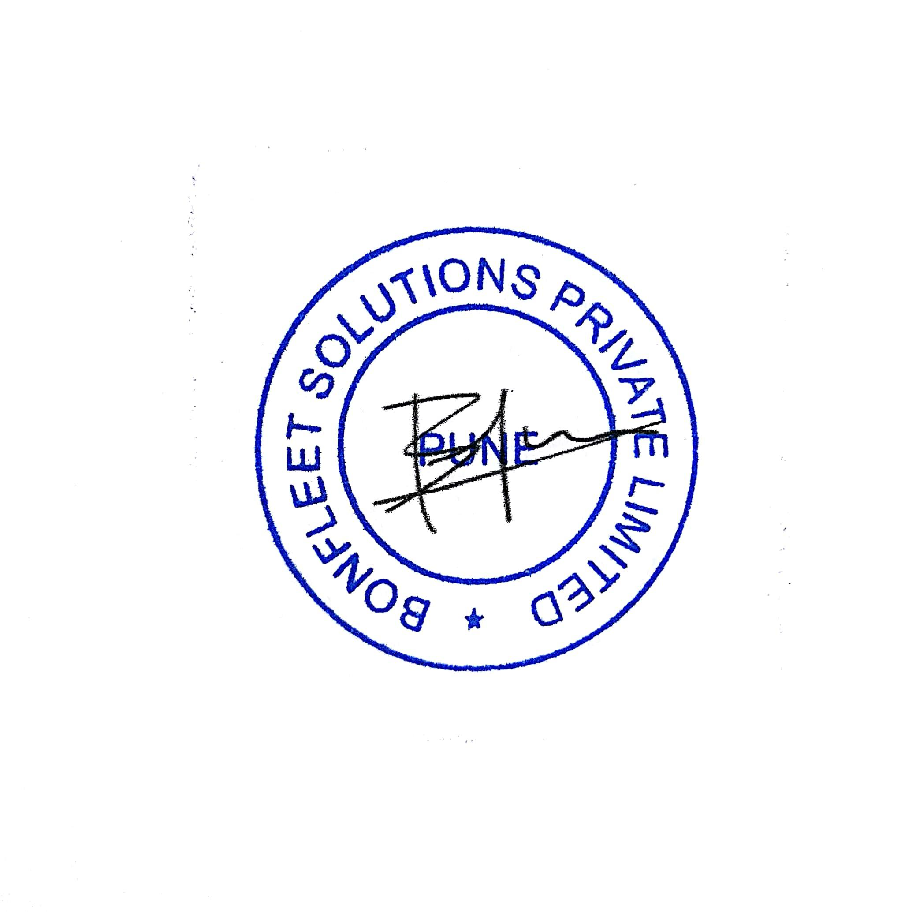

_____________________________

Name & Title:

MR. Bhasker Kode

Founder

DIN:07492400

In the presence of:

_____________________________

Witness Name:

**SIGNED** by Mr Laxmiraman Soni

In the presence of:

_____________________________

Witness Name: